

Developer's Guide

Redisoft_GCalendar2XLS_POC

May,2017

Version 1.0

Corporate Office & Development
Center
DAMCO SOLUTIONS PVT. LTD.
108, HSIDC Industrial Complex, Sector 31,
Faridabad – 121008, Haryana.

Document Revision History

Date | Version | Description | Author | Reviewer | Approver
9th May 2017 | 1.0 | Technical details | Rohit Agarwal | Chetan Kaushik | Mamta Talwar

Project Information
Project Name: | Redisoft_GCalendar2XLS_POC
Project Manager: | Chetan Kaushik
Project Id: | Gcalendar2XLS 1.0
TABLE OF CONTENTS

1 Executive Summary 4
1.1 Project Overview 4
2 Project Description 4
2.1 Purpose 4
2.2 User Characteristics 4
2.3 Dependencies 4
3 Architecture 4
3.1 Technology stack 4
3.2 Implementation Design Architecture 5
4. Modules 6
4.1 Controller module 6
4.2 CSV Reader module 6
4.3 Excel Generator module 6
4.4 Factory module 6
4.5 Exception module 6
4.6 Util module 6
4.7 Service module 6
4.8 Resources module 6
5. How to generate Credential file 7

- Executive Summary
  - Project Overview

The objective of this pilot project is to provide a Java/j2ee solution, where program will read a .string as an input from csv file, which will further be used to process Google calendar’s events and will store the information of events in output .xls file as per the pre-provided template .xls file.

This software can be very useful, if user wants to have all his/her important google calendar’s activities at one single place like .xls instead of going through the multiple

- Project Description

2.1 Purpose

To facilitate the google user to export his/her important google calendar events to pre-defined output file in .xls format.

2.2 User Characteristics

Require Google user profile to use this application.

2.3 Dependencies

List of dependencies:

- Google oauth client jetty
- Google API service calendar
- Apache POI
- Commons file upload
- Log4j

- Architecture

3.1 Technology stack

- Microsoft windows platform
- Tomcat server
- Java 1.8
- JSP/Servlet
- Maven build tool
- Google API

3.2 Implementation Design Architecture

This application follows MVC model for development.
- At front end(View) JSP with css has been used to provide user interface design.
- At Back-end, Servlet is used as controller to process all incoming requests.
We are not using any database, so modal layer is not being used.
- From controller we are calling Google API for event details through service layer.

Functional Design Architecture

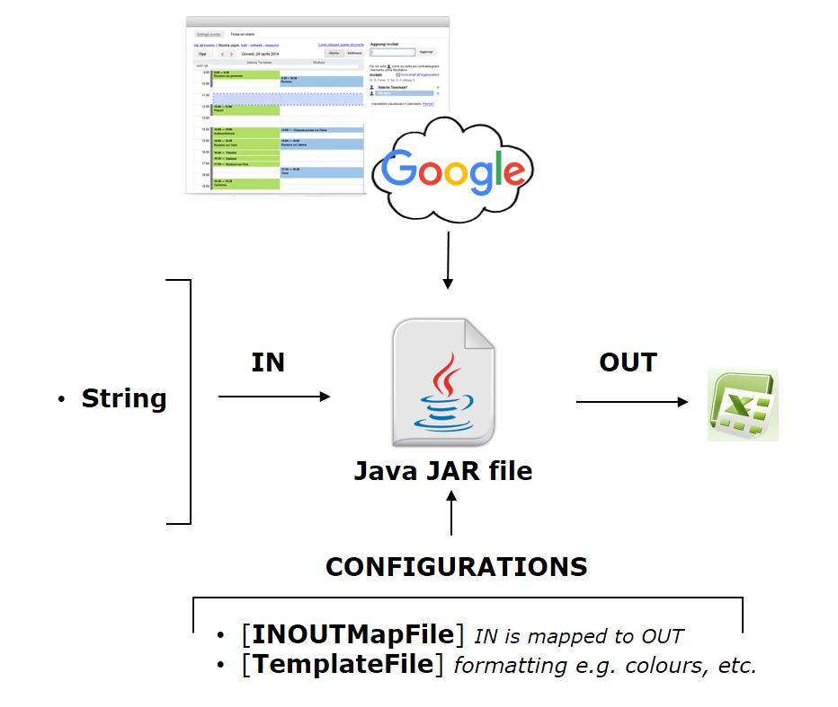

Modules

This project contains different module for different types of operations.

4.1 Controller module

com.google.calendar.controller : Package contains files for controller class which is a java servlet.

4.2 CSV Reader module

com.google.calendar.csv.reader : Package contains classes and interfaces for CSVreader module. This module worked as CSV file validation and generate input for Google calendar API.

4.3 Excel Generator module

com.google.calendar.excel.output : Package contains classes and files for export excel file with google calendar events.

4.4 Factory module

com.google.calendar.factory : Package contains factory classes which is used to create service classes object.

4.5 Exception module

com.google.calendar.exception : Package contains custom Exception classes .

4.6 Util module

com.google.calendar.util : Package contains helper classes for CSV reader and excel generator module.

4.7 Service module

com.google.calendar.service : Package contains service layer classes to call Google calendar API for event details.

4.8 Resources module

Resource module contains file which required by this application at runtime.

- client_secret.json file which contains information about user credentials. It’s required by Google API for authentication.
- Timesheet.xls file which is default template for generated excel.
- Configuration.properties file which contains header information of template.
- log4j.properties file which contains information for logger of application

5. How to generate Credential file

Google is not providing support to hit their calendar API with user name and password through java code. For authentication purpose they have moved to OAuth API. OAuth API required JSON file with some user details. You can create JSON file by following below steps.

By default, we have provided the “client_secret.json”. If you want to create your own, you can create it using the following procedure: -

5.1 Step to Turn on the Google Calendar API and create JSON file

- Use this wizard to create or select a project in the Google Developers Console and automatically turn on the API.
- Click Continue, then Go to credentials.
- At the top of the page, select the OAuth consent screen tab. Select an Email address, enter a Product name if not already set, and click the Save button. (These are the options you will display to the user when you asking for the permission for the app via consent screen).
- Select the Credentials tab, click the Add credentials button and select OAuth 2.0 client ID.
- Select the application type Other, enter the name of the app e.g. “Google Calendar API Quickstart”, and click the Create button.
- Click OK to dismiss the resulting dialog.
- Click the (Download JSON) button to the right of the client ID.
- Move this file to your working directory and rename it client_secret.json. This is the one that you will use to communicate with the Google app via Java program.

